The JK Reflexology Trend: Is It Worth the Hype?

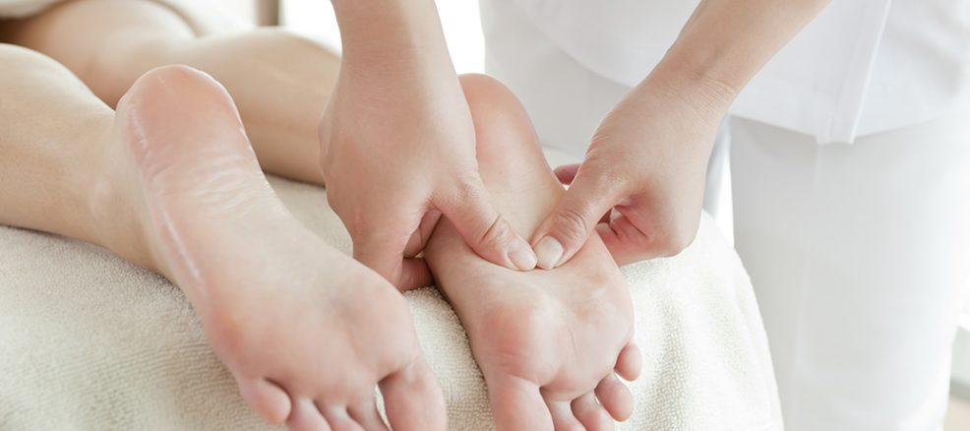

Reflexology, a well established practice with establishes in old Egypt, China, and India, offers an all encompassing way to deal with further developing wellbeing and in general prosperity. JK Reflexology hangs out in this field as an extraordinary work on, mixing custom with current procedures to make enduring wellbeing benefits. In this article, we jump profound into the mysteries of JK Reflexology, making sense of how it can alter your wellbeing process.

What is JK Reflexology?

JK Reflexology is a particular type of reflexology [JKリフレ](https://jkrefre.com/) that spotlights on animating explicit reflex focuses in the hands, feet, and ears to advance regular mending all through the body. By applying vital strain to these areas, specialists enact the body's natural capacity to adjust itself. This technique isn't just about unwinding; it addresses different physical, profound, and emotional wellness concerns.

Through steady meetings, people can encounter help from constant agony, further developed course, upgraded mind-set, and better generally wellbeing. JK Reflexology expands upon the standards of customary reflexology while integrating progressed strategies to accomplish ideal outcomes.

How Does JK Reflexology Function?

The Science Behind Reflex Focuses

The basic guideline of JK Reflexology is the planning of reflex focuses on the feet, hands, and ears to relating organs and frameworks inside the body. By focusing on these zones, the professional invigorates sensitive spots, which convey messages to the focal sensory system, setting off the body's recuperating components.

For example:

Feet: Reflex focuses on the feet are associated with organs like the liver, kidneys, and lungs.

Hands: Hand reflexology targets regions connected with the shoulders, stomach related framework, and spine.

Ears: These focuses compare to the whole body, making ear reflexology especially successful for stress alleviation.

Improved Methods in JK Reflexology

Not at all like standard reflexology rehearses, JK Reflexology utilizes progressed pressure regulation and creative devices to enhance the mending impacts. By joining profound tissue pressure methods with delicate controls, professionals can address both surface-level and more profound uneven characters.

The Groundbreaking Advantages of JK Reflexology

1. Stress Decrease and Mental Clearness

Stress is one of the most well-known difficulties of current life, and JK Reflexology offers a strong arrangement. By invigorating reflex focuses associated with the sensory system, meetings assist with lessening cortisol levels, advancing unwinding and mental clearness.

Clients report feeling lighter and more engaged after only a couple of meetings.

Predictable medicines can likewise assist with lightening side effects of uneasiness and despondency.

2. Relief from discomfort Without Prescription

Whether you're battling with persistent back torment, headaches, or joint uneasiness, JK Reflexology gives a harmless method for overseeing torment. Reflex focuses connected with impacted regions are animated, diminishing irritation and further developing portability.

Joint inflammation Help: Numerous clients experience huge improvement in joint agony through designated reflexology.

Cerebral pain The board: Reflex focuses associated with the head and neck can ease strain, offering alleviation from headaches.

3. Further developed Course and Detoxification

Solid flow is fundamental for supplement conveyance and poison expulsion. JK Reflexology assists support with blooding stream by enacting the vascular framework through reflex feeling.

Improved oxygen and supplement conveyance to cells.

Sped up expulsion of poisons from the body, advancing in general essentialness.

4. Hormonal Equilibrium

Hormonal awkward nature can disturb all that from rest examples to mind-set and digestion. JK Reflexology upholds endocrine wellbeing by focusing on reflex focuses related with chemical delivering organs like the thyroid, adrenal organs, and ovaries/testicles.

Oversees side effects of PMS and menopause.

Further develops energy levels and profound steadiness.

Who Can Profit From JK Reflexology?

People Looking for Comprehensive Wellbeing

In the event that you're searching for a characteristic way to deal with wellbeing, JK Reflexology offers a medication free method for accomplishing balance.

Those Overseeing Ongoing Circumstances

From diabetes to fibromyalgia, JK Reflexology supplements ordinary clinical medicines, overseeing side effects and working on personal satisfaction.

Occupied Experts

Stress and weakness can negatively affect execution. Reflexology meetings assist with reviving the brain and body, improving efficiency.

What's in store During a JK Reflexology Meeting

1. Beginning Interview

The principal meeting includes an itemized evaluation of your wellbeing concerns, way of life, and objectives. The expert guides out a customized reflexology plan custom-made to your requirements.

2. The Treatment Cycle

Unwinding: You'll start by resting in an agreeable position.

Feeling: The expert applies exact strain to reflex focuses utilizing their hands or concentrated apparatuses.

Criticism: You might feel slight delicacy in specific regions, which shows energy blockages that need consideration.

3. Post-Meeting Impacts

Numerous clients report feeling profoundly loose and revived following a meeting. Some experience a brief detox response, like gentle weakness or expanded pee, as the body kills poisons.

Do-It-Yourself Reflexology: Might You at any point Practice JK Reflexology at Home?

While proficient meetings are exceptionally successful, integrating reflexology procedures into your taking care of oneself routine can enhance the advantages. This is how it's done:

Foot Rollers: Utilize a foot roller to invigorate reflex focuses on the bottoms of your feet.

Hand Reflexology: Apply delicate strain to the focal point of your palms to ease pressure.

Ear Reflexology: Delicately rub the external edges of your ears for a fast unwinding support.

Be that as it may, for ongoing or complex issues, proficient direction is fundamental to accomplish the best outcomes.

Why Pick JK Reflexology?

The universe of reflexology is tremendous, yet JK Reflexology stands apart because of its obligation to development, client care, and results-driven procedures. Here's the reason:

Experienced Specialists: All advisors are exceptionally prepared and ensured in cutting edge reflexology methods.

Customized Approach: Every meeting is custom-made to the client's special wellbeing profile.

Demonstrated Results: Various clients have encountered significant enhancements in their wellbeing and prosperity.

End: Embrace Wellbeing with JK Reflexology

JK Reflexology offers something other than a wellbeing treatment — it gives a pathway to further developed wellbeing, unwinding, and balance. Whether you're looking for help from ongoing agony, overseeing pressure, or basically hoping to upgrade your personal satisfaction, this extraordinary practice is your response.

Book your meeting today and open the privileged insights of JK Reflexology to change your wellbeing process. Your body, psyche, and soul will much obliged.